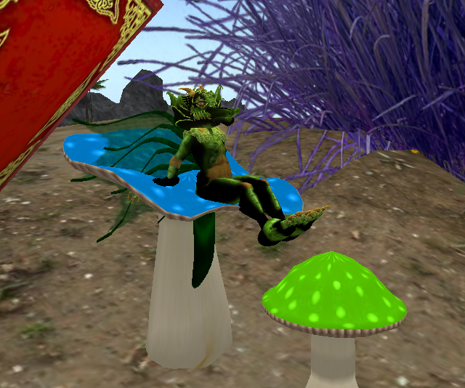
A small dragon sat on a blue mushroom.

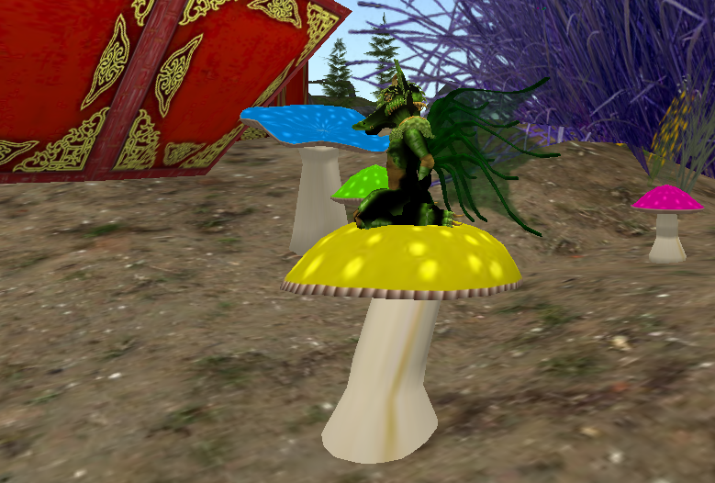
Then the dragon moved to the yellow mushroom.

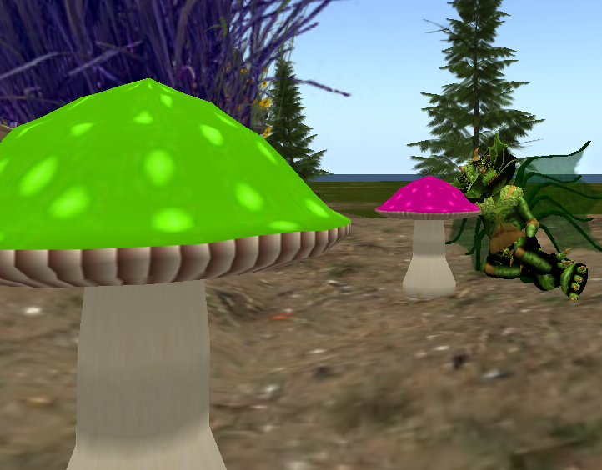
The dragon was not comfortable, so the dragon leaned on the pink mushroom.

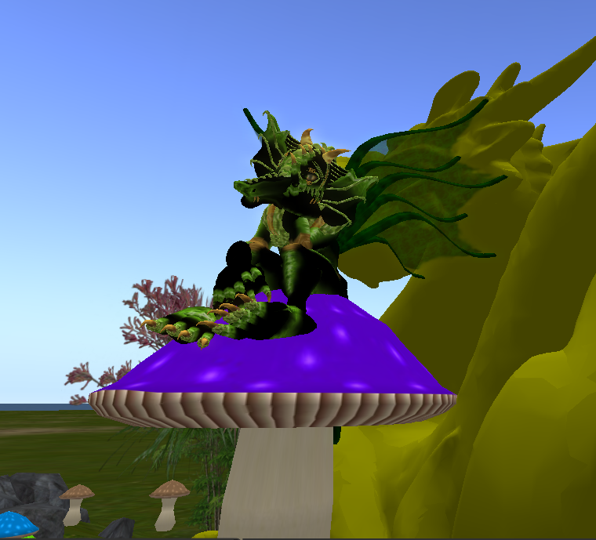
The dragon was even bored with the purple mushroom.

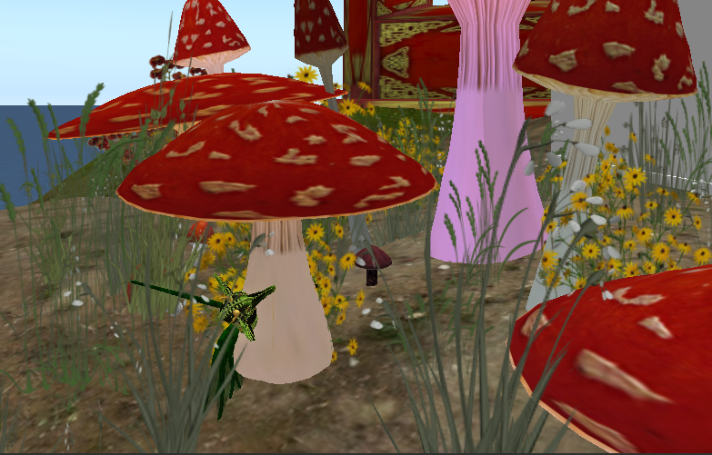
When the dragon tried to sit on the red mushroom, the dragon fell to the ground!

